Simulation of Telemetry Data Ingestion to Time-Series Database and Visualization using Grafana, Power BI and Tableau
Objective:
To simulate IoT telemetry data (temperature, humidity and pressure from four sensors), model its ingestion into a time-series database, visualise it with dashboard-style graphs, and export the stored records as a CSV file that dashboard tools such as Grafana, Power BI and Tableau can import.
Procedure:
- Generate 500 telemetry records at 10-second intervals starting 21 Oct 2026, 09:00, each assigned randomly to Sensor_A, Sensor_B, Sensor_C or Sensor_D, with temperature (mean 27 C, SD 3.2), humidity (mean 58%, SD 8, limited to 20-95%) and pressure (mean 1013 hPa, SD 5).
- Simulate time-series database ingestion: each record is Stored with probability 0.985 and Failed otherwise; keep only the stored records.
- Compute the ingestion success rate and the average temperature, humidity and pressure of the stored records.
- Plot temperature vs time, humidity vs time, ingestion status (stored vs failed) and average temperature by sensor as a dashboard-style figure.
- Export the stored records to telemetry_data.csv, which can be loaded into Grafana, Power BI or Tableau for visualisation.
Program:
import numpy as np
import pandas as pd
import matplotlib.pyplot as plt
from datetime import datetime, timedelta

np.random.seed(17)

# 1. Generate simulated telemetry data
N = 500
start = datetime(2026, 10, 21, 9, 0)

df = pd.DataFrame({
"timestamp": [
start + timedelta(seconds=10*i) for i in range(N)
],
"device_id": np.random.choice(
["Sensor_A", "Sensor_B", "Sensor_C", "Sensor_D"], N
),
"temperature_C": np.random.normal(27, 3.2, N).round(2),
"humidity_pct": np.random.normal(58, 8, N).clip(20, 95).round(2),
"pressure_hPa": np.random.normal(1013, 5, N).round(2)
})

# 2. Simulate time-series database ingestion
df["ingestion_status"] = np.where(
np.random.random(N) < 0.985, "Stored", "Failed"
)

stored = df[df["ingestion_status"] == "Stored"].copy()
failed = N - len(stored)

print("=" * 55)
print("TELEMETRY DATA INGESTION SIMULATION")
print("=" * 55)
print("Total records generated:", N)
print("Records stored:", len(stored))
print("Records failed:", failed)
print(f"Ingestion success rate: {len(stored)/N*100:.2f}%")
print(f"Average temperature: {stored['temperature_C'].mean():.2f} °C")
print(f"Average humidity: {stored['humidity_pct'].mean():.2f}%")
print(f"Average pressure: {stored['pressure_hPa'].mean():.2f} hPa")

print("\nSample telemetry records:")
print(stored[[
"timestamp", "device_id", "temperature_C",
"humidity_pct", "pressure_hPa"
]].head(8).to_string(index=False))

# 3. Create dashboard-style graphs
fig, ax = plt.subplots(2, 2, figsize=(14, 9))

# Temperature vs time
ax[0, 0].plot(stored["timestamp"], stored["temperature_C"])
ax[0, 0].set_title("Temperature vs Time")
ax[0, 0].set_ylabel("Temperature (°C)")
ax[0, 0].tick_params(axis="x", rotation=25)
ax[0, 0].grid(True, alpha=0.3)

# Humidity vs time
ax[0, 1].plot(stored["timestamp"], stored["humidity_pct"])
ax[0, 1].set_title("Humidity vs Time")
ax[0, 1].set_ylabel("Humidity (%)")
ax[0, 1].tick_params(axis="x", rotation=25)
ax[0, 1].grid(True, alpha=0.3)

# Database ingestion status
ax[1, 0].bar(
["Stored", "Failed"],
[len(stored), failed]
)
ax[1, 0].set_title("Time-Series Database Ingestion")
ax[1, 0].set_ylabel("Number of Records")
ax[1, 0].grid(axis="y", alpha=0.3)

# Average temperature for each sensor
means = stored.groupby("device_id")["temperature_C"].mean()
ax[1, 1].bar(means.index, means.values)
ax[1, 1].set_title("Average Temperature by Sensor")
ax[1, 1].set_ylabel("Temperature (°C)")
ax[1, 1].grid(axis="y", alpha=0.3)

plt.tight_layout()
plt.savefig("telemetry_dashboard.png", dpi=180)
plt.show()

# 4. Export records for dashboard tools
stored.to_csv("telemetry_data.csv", index=False)

print("\nSimulation completed successfully.")
print("Dashboard graphs saved as telemetry_dashboard.png")
print("Data exported as telemetry_data.csv")

# Download both files in Google Colab
from google.colab import files
files.download("telemetry_dashboard.png")
files.download("telemetry_data.csv")

Output:
=======================================================
TELEMETRY DATA INGESTION SIMULATION
=======================================================
Total records generated: 500
Records stored: 497
Records failed: 3
Ingestion success rate: 99.40%
Average temperature: 27.08 °C
Average humidity: 57.95%
Average pressure: 1013.37 hPa

Sample telemetry records:
timestamp device_id temperature_C humidity_pct pressure_hPa
2026-10-21 09:00:00 Sensor_D 26.53 66.83 1007.26
2026-10-21 09:00:10 Sensor_B 33.57 56.99 1011.51
2026-10-21 09:00:20 Sensor_D 30.67 54.76 1007.19
2026-10-21 09:00:30 Sensor_C 27.24 62.61 1011.62
2026-10-21 09:00:40 Sensor_C 24.25 87.66 1010.95
2026-10-21 09:00:50 Sensor_B 25.76 71.61 1016.51
2026-10-21 09:01:00 Sensor_A 32.14 57.74 1011.55
2026-10-21 09:01:10 Sensor_B 30.52 57.97 1003.38

Simulation completed successfully.
Dashboard graphs saved as telemetry_dashboard.png
Data exported as telemetry_data.csv

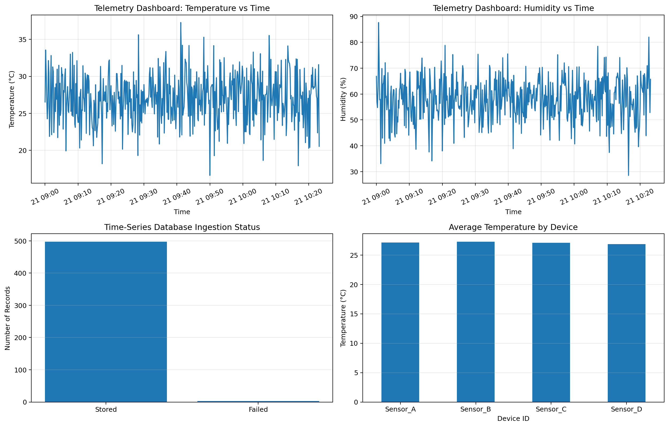
Fig. 1: Telemetry dashboard (temperature, humidity, ingestion status, average temperature by sensor)
Node-red: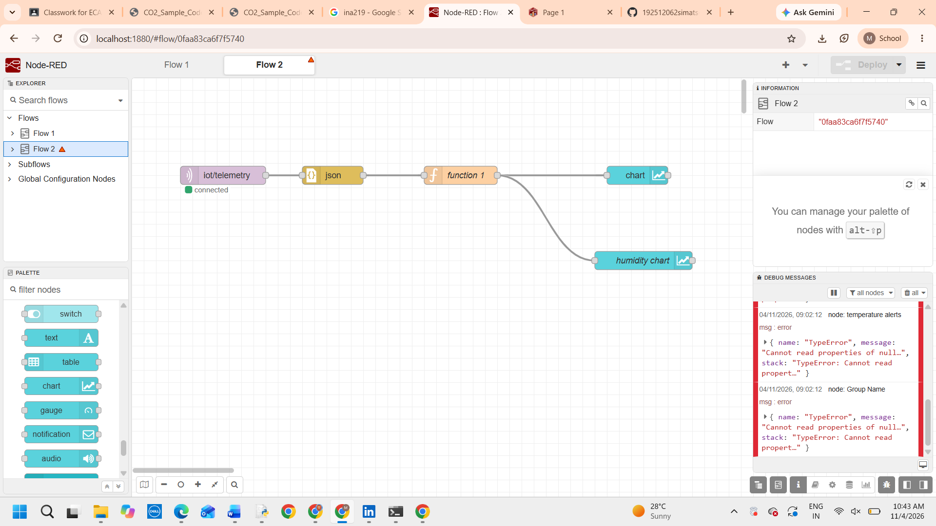
Output: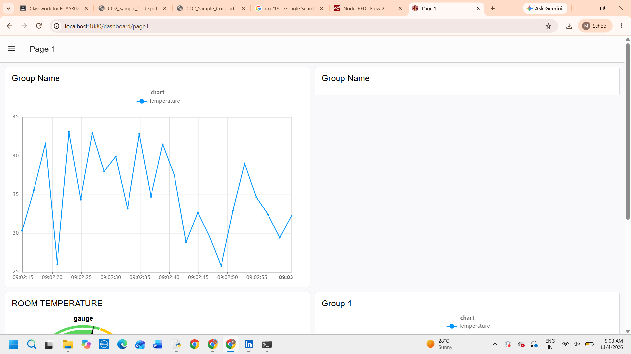

Results:
Metric | Value
Total records generated | 500
Records stored / failed | 497 / 3
Ingestion success rate | 99.40%
Average temperature | 27.08 °C
Average humidity | 57.95%
Average pressure | 1013.37 hPa

Sensor | Average temperature (°C)
Sensor_A | 27.13
Sensor_B | 27.24
Sensor_C | 27.09
Sensor_D | 26.85

497 of the 500 records were stored and 3 failed, an ingestion success rate of 99.40% against the configured 98.5%. Temperature varied between about 16.6 and 37.3 C and humidity between about 28.5% and 87.7%, with no trend over the 83-minute period. The average temperature is almost the same for all four sensors (26.85 to 27.24 C), as expected because every sensor draws from the same distribution.
Result:
The simulated telemetry pipeline stored 99.40% of the generated records, and the stored time-series data was plotted as a dashboard-style view of temperature, humidity, ingestion status and per-sensor averages. The records were exported as a CSV file, the common input format for Grafana, Power BI and Tableau, so the same data can be visualised in those tools. All values are simulated, not measured from real sensors.

